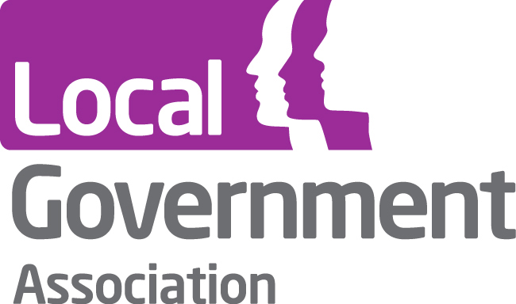****

**Making Safeguarding Personal 2014 - 17**

**Invitation to participate in sector led improvement work**

Making Safeguarding Personal is a key component of the improvement work that is being led by ADASS and LGA.

In 2011-12, we developed ‘Making Safeguarding Personal: A Toolkit of Responses’.

In 2012-13, we worked with a small number of councils to testbed an outcomes focussed approach and a range of responses to working with people in safeguarding circumstances.

For 2013-14, the Making Safeguarding Personal (MSP) programme produced enthusiastic engagement of a significant number of council staff and very encouraging results both for people supported by safeguarding services and for social work development.

TEASC and an advisory group that has included RiPfA, The College of Social Work and key academics have supported these initiatives. Funding has been secured through DH for further work for the next three years to support both the implementation of the Care Bill and its associated statutory guidance and safeguarding improvement. This is therefore an invitation to express interest in taking this forward in your council area *for both those that have already been involved and those that want to be involved from now on from now on.*

If you were involved last year (phase 1) please let us know what you would like to do next.

If you haven’t been involved so far then please do let us know how you would like to be involved from now on.

Whilst this is neither a competition nor an accreditation process, it has been helpful shorthand to think of participation at three levels. These are:

|  |  |
| --- | --- |
| Level | What this involves |
| ‘Bronze’ | Developing an outcomes focussed, person centred approach to safeguarding.  Aggregating outcomes for Board as quality measure  Sharing results and feedback of impact. |
| ‘Silver’ | As above and/or working to develop one or more responses (from the MSP toolkit or elsewhere) to support the realisation of the outcomes people want.  Sharing impact and outcomes. |
| ‘Gold’ | As above – plus councils approach HEIs or others to undertake more formal evaluation. |

A range of activities to support you is being planned and will be finalised once we know at what levels you wish to be involved.

**How to sign up:**

If you would like to take part then **please e-mail** [**cathiewilliams@btinternet.com**](mailto:cathiewilliams@btinternet.com) **by the 30th May for the first phase,** with an indication of what level you would wish to engage at. IF you are unable to sign up byt that date please indicate your preferred level of engagement for the next phase by the 30th June.

Cathie Williams, LGA Adult Safeguarding

Adi-Cooper, Co-Lead, ADASS Safeguarding