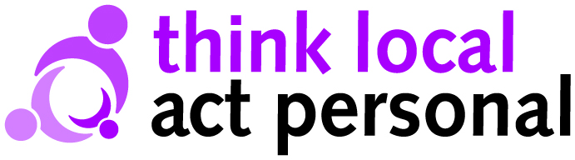
Developing the Power of Strong Inclusive Communities to Boost Health and Well-Being
A Support Offer from Think Local Act Personal in Partnership with Public Health England
Introduction
The Think Local Act Personal (TLAP) Building Community Capacity programme has for several years gathered and disseminated innovative practice and evidence of the impact of social capital interventions in health and social care. Building on this, and working in partnership with Public Health England and Professor Knapp and colleagues from LSE, we are now developing a practical framework for Health and Well Being Boards. This will help HWB boards to identify and implement evidence based interventions aimed at:
- Improving health and well-being by supporting the inclusion and maximising the contribution of older and disabled people in local communities
- Avoiding, delaying or reducing unnecessary use of acute/long term health and social care via the building or maintenance of social capital
A draft framework has been produced and we now wish to test and further develop it in practice so that the final version will be of maximum use to HWBs. Between October and April 2014 we will:
- Provide a group of HWB boards with a draft framework for strategy and activity to build social capital, linking to examples and evidence
- Support an exemplar group of HWBs to use the draft framework in developing and implementing local plans, working in synergy with other initiatives and offers (LGA, regional networks etc.)
At the end of this period we will publish and disseminate a final framework and hope to further support its practical use.
Our offer
Each HWB board involved in this phase of the project will be supported to review existing local strategy and priorities in the context of the TLAP framework, identify what interventions and activities can build inclusion and social capital while helping local people reduce their need for acute services and to build relevant action into their strategies going forward. Each board will be allocated a TLAP facilitator/liaison to co-ordinate input.
Following initial diagnosis/planning, each board will have a small allocation of consultancy resource to be deployed flexibly on a negotiated basis to develop and start to deliver the action plan. In addition, boards will identify where evidence can support their plans and where possible LSE colleagues will provide assistance with this via their use of an approach called Decision Modelling. Most activity will take place locally but we will also aim to facilitate peer support where appropriate and provide a forum for exchange via our web-site and project webinars. In outline:
- A local, facilitated and co-productive review and planning session, using the framework and TLAP tools in context of local HWB strategy.
- Local use of agreed level of consultancy support based on initial session
- Evidence support via LSE
- Facilitate peer support
- Web-based forum for exchange and good practice
Your commitment
In order to join the project we would expect:
- Strategic level Board commitment to undertake the review and incorporate elements of the framework into the strategy and priorities of the Board
- A senior level liaison with the project who will co-ordinate locally
- Commitment to bring together relevant senior agency/Board representatives for the planning and diagnostic session along with representatives of local people using services
- Agreement to make active use of the project to develop local plans
- Commitment to provide written information about the use of the framework to develop local plans in order to support framework development
- Costs of local meetings covered
Application to join the programme
Depending upon finalisation of available resources, we will be able to support between 6 and 12 HWB boards. Application is via an expression of interest which should:
- Be signed by a member of the Board
- Nominate a senior local liaison
- Agree to the commitments listed above
- Confirm your ability to hold a local planning session in November/December
- Describe, in no more than 500 words how you would intend involvement in this project would support delivery of HWB board priorities and build community capacity
Expressions of interest should be received no later than October 21st to Corrine.moutou@scie.org.uk
For more information please contact Martin Routledge 07788 184625

